MySQL

**Exercise 5**

1. Write a stored function to take three parameters, the sides of a triangle. The sides of the triangle should be accepted from the user. The function should return a Boolean value:- *true* if the triangle is valid, *false* otherwise. A triangle is valid if the length of each side is less than the sum of the lengths of the other two sides. Check if the dimensions entered can form a valid triangle.

Ans:

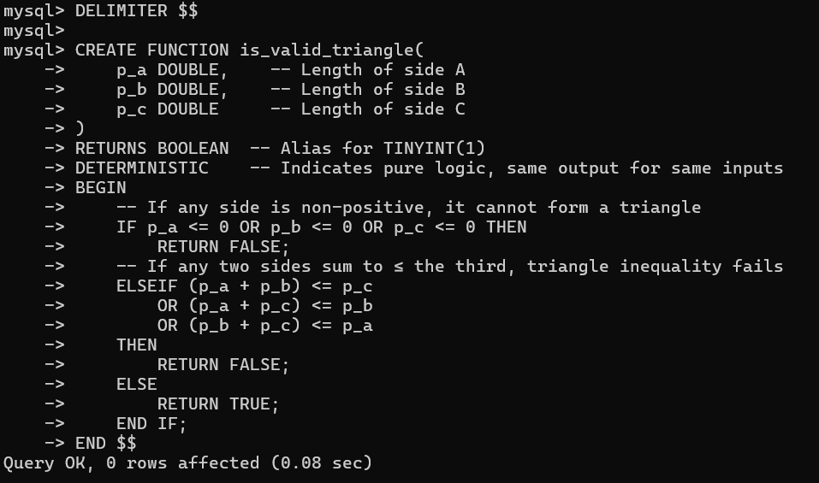

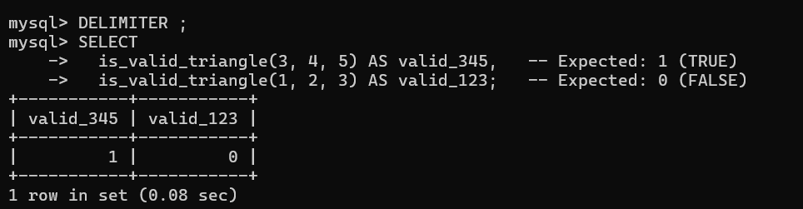

2. Write a function that generates a random number between 1 and 10. Use any logic of your choice to achieve this.

mysql> DELIMITER //

mysql>

mysql> CREATE FUNCTION random_1_to_10()

-> RETURNS INT

-> DETERMINISTIC

-> BEGIN

-> RETURN FLOOR(1 + (RAND() * 10));

-> END//

Query OK, 0 rows affected (0.01 sec)

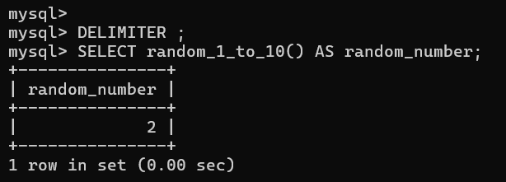

1. Create a function that accepts a string of *n* characters and exchanges the first character with the last, the second with the next – to – last, and so forth until *n* exchanges have been made. What will the final string look like? Write the function to verify your conclusion.

Ans:

